**FACE MONITORING SYSTEM FOR SAFETY MEASURES** Tushit Agarwal ([tushit.agarwal.cs.2016@miet.ac.in](mailto:tushit.agarwal.cs.2016@miet.ac.in)), Tavishi Gupta ([tavishi.gupta.cs.2016@miet.ac.in](mailto:tavishi.gupta.cs.2016@miet.ac.in)), Sparsh Gupta ([sparsh.gupta.cs.2016@miet.ac.in](mailto:sparsh.gupta.cs.2016@miet.ac.in)), Sidharth Jain ([sidharth.jain.cs.2016@miet.ac.in](mailto:sidharth.jain.cs.2016@miet.ac.in)), Vishal Jayaswal ([vishal.jayaswal@miet.ac.in](mailto:vishal.jayaswal@miet.ac.in))

***Abstract-*** Road safety is the biggest concern around the globe. Most of these accidents occur due to driver’s drowsiness and fatigue-ness. Driver’s drowsiness or short sleep can lead to many mishaps on roads like failing to apply break when needed, losing control of vehicle on highways at high speed, disbalancing the vehicle while overtaking etc. Almost all drivers may face this condition due to reasons like long driving, weather effects etc. Ensuring safety at this point becomes very essential as one mistake of any driver can put many lives to threat. Though human error can’t be removed completely but it can be reduced to a significant number. This project mainly used in detecting if the driver is in fatigue or drowsy state or not.

In this the driver will be under computer-vision that will examine him by reading his face and detecting with the help of OpenCv - the image processing technique. An alarm will be raised if the driver is found to be present in any of the above conditions or is going in that condition. This will alert the driver and thus can prevent road accidents to a much larger extent.

**Ke*ywords-* Drowsiness, fatigueness, computer-vision, OpenCV, Image Processing.**

**I. INTRODUCTION**

Safety and security are quite essential while travelling. This does not limit to vehicle robustness and its security features but also includes road accidents and other driving skills. Increasing number of deaths due to road accidents is one of the major issues all over the world. According to a recent survey conducted by the World Health Organisation, approximately 3700 people globally lose their lives daily in road accidents. Out of these, approximately, 20% death reasons are driver’s less consciousness on the road like distraction, drowsiness, fatigueness etc.

Drowsiness is the state of “need for sleep” and fatigueness is defined as the “tiredness due to excessive workload”. In both the scenarios, the person is quite unaware of the events occurring in his surroundings similar to the drunk state. Drowsiness of the driver can lead to threat of many lives on the road. This short sleep may result in vehicle imbalancing, unnecessary road cuts and collisions. To eliminate this issue and provide security to drivers, our project detects the driver’s drowsiness using image processing and ML. The aim of our project is to detect driver’s drowsy state as soon as possible and blow a buzzer which alerts the driver.

This project mainly detects drowsiness of a person by continuously scanning the eyes and face and recording the blinks of the eye. An alarm will be raised if the person’s eyes shut for a long period of time. Similarly, a trigger also raises the alarm if a person's eye is found to be distracted by some object, away from the road. This rising of alarm will alert the driver and thus necessary steps could be taken to avoid mishaps. Several other methods can also be implemented to check driver’s drowsiness and distraction as depicted in Fig-1.

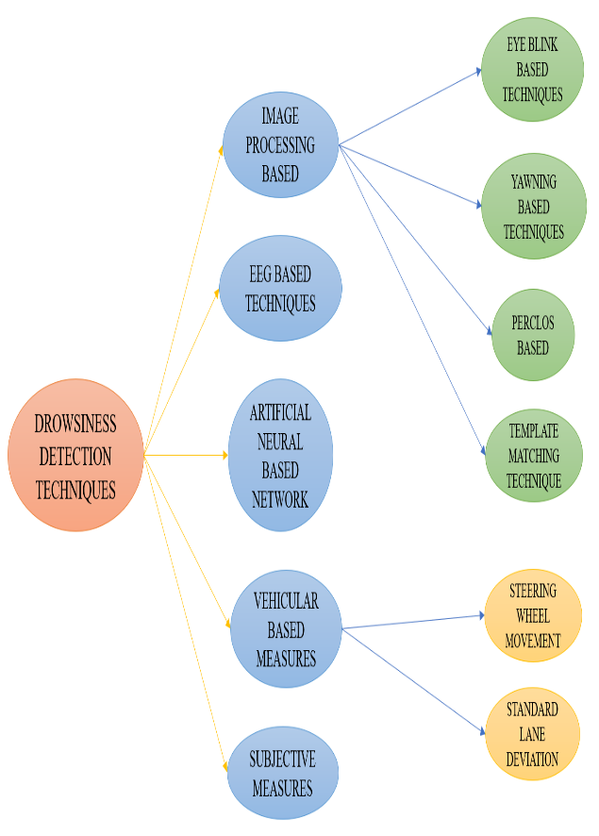

**Fig-1 Drowsiness Detection Techniques**

**II. PROCEDURE**

The process can be divided into three main steps as depicted in Fig-2.

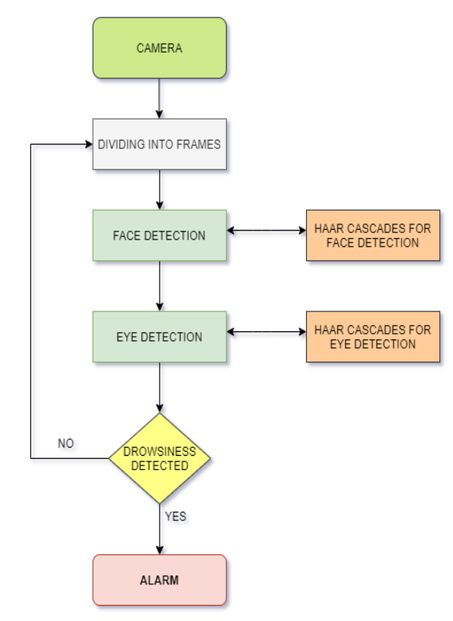

**Fig-2 Block Diagram of Face Monitoring System for Safety Measures**

1. *Capturing the Image:*

First of the image is captured using the device webcam or with the specific hardware that supports recording a video of at least 30fps. The image is then divided into several frames for examining the face and eyes of the person.

1. *Locating the Facial Landmarks:*

If the face is found, we apply a facial landmark detection with the help of “shape predictor image landmark object detection” model of TensorFlow to locate the mouth and eyes of the person. HaarCascades classifying algorithm is used to detect the frontal face of the person. This algorithm also predicts several other objects to identify the distraction sources of the driver other than drowsiness case.

1. *Calculating the EAR:*

As the eye region is spotted on the face, we now compute the Eye Aspect Ratio (EAR) using PCA (Principle of Component Analysis) with the help of a given formula.

$$EAR=\frac{\left| X2-X6 \right|+| X3-X5|}{2* | X1-X4 |}$$

where X1, X2 …. X6 are 2D facial landmark locations.

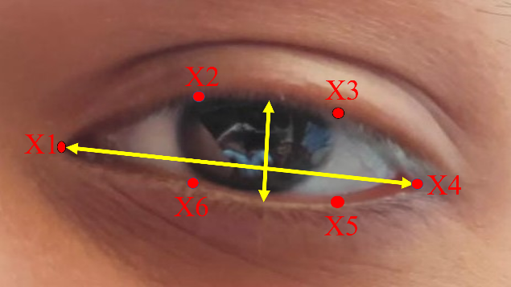

**Fig3 Principal of Component Analysis**

If the calculated EAR depicts that the eyes have been closed longer than the predefined set threshold time, then we’ll hear a beep sound as an indicator alerting the driver.

**III. PROPOSED SYSTEM**

We have seen the capturing of images and extracting the information from the image. The main methods fulfilling all these requirements are OpenCv, TensorFlow, object detection model using HaarCascades and shape predictor facial recognition. The whole system works on this process only, as explained in Fig-4.

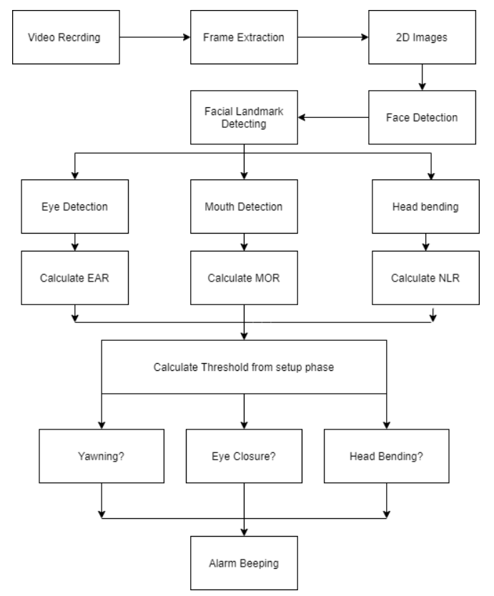

**Fig-4 Flow Chart of Face Monitoring System for Safety Measures**

The working of the program is mainly categorised into the following parts:

1. Capturing the image
2. Pre-process the picture
3. Face extraction and 2D image conversion
4. Find facial landmarks on the image
5. Calculate EAR from the image
6. Predict drowsiness from calculations.
7. Raising an alert.

1. *Capturing the Image:*

Initially, an image is captured automatically as an input via the webcam or specific hardware through the OpenCV function. Fig-6 shows the GUI of the project and image captured.

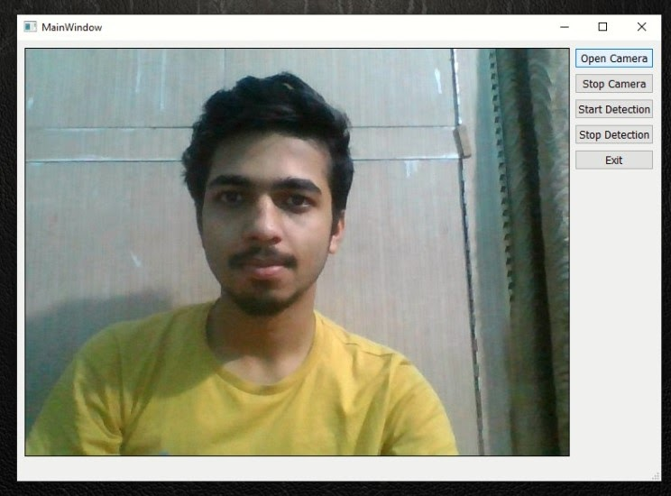

**Fig-5 System GUI and image captured**

2. *Pre-process the picture:*

Converting the RGB (Red-Green-Blue) image into grey-black image and then converting the image into binary form to process the data. After the image conversion gets successful, we use that data to predict the shapes on that image.

*3.Face extraction and 2D image conversion:*

In this,Eigen based facial algorithm is used to convert 3D image into 2D image which is captured from the webcam. The face of a human and other objects are then extracted using Gaussian Skin model and rectangular box techniques to create the Eigen faces. These eigen faces are then divided into frames for further steps. Fig-7 shows the extracted 2D facial image of a human.



**Fig-6 Resulting facial feature pixel**

4. *Find facial landmarks on the image:*

For locating the facial landmarks - eyes, mouth and ears on the face, we have taken support of the Scipy python module. This module helps us to calculate the Euclidean distance from one end of the face to another at various points to accurately locate the face. The main algorithm used here is Viola Jones algorithm.

The face land-marks are produced with the help of python’s DLIB module. These landmarks are generated as an index list. Hence, to generate eye regions from produced sets of face land-marks, we need to know the exact array slice indexes which will ease us to generate the eye regions from array slices. Fig-8 shows the facial indexing.

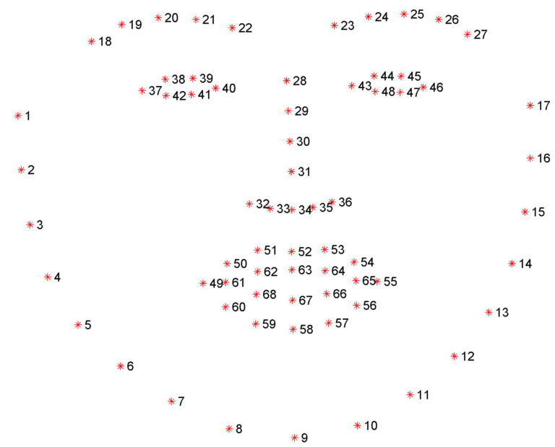

**Fig-7 Visualise the 68 face land-mark co-ordinates from predefined dataset**

5. *Calculate EAR from the image:*

Next, we will compute the EAR (Eye Aspect Ratio). EAR is the estimation of an eye-opening state. It is a fixed value when the eye-lid is open and goes down to zero when eye-lids are shut. Calculating computational blinks in EAR involves the following combinations: Localisation of the eye, thresholding to find the white area of the eye, indicating the eye blinking by determining the disappearing of eye whites.

6. *Predict drowsiness from calculations:*

The calculated EAR is examined and compared with the predetermined threshold value which is 0.3 for this system. If the calculated EAR is greater than 0.3, then the system predicts drowsiness state to be true, else false. For yawning analysis, if the mouth ratio is found to be greater than 0.5 and up to 6 frames per seconds, driver is assumed to be entering in the state of drowsiness. Fig-9 shows the graph plotted for the EAR over a fixed span of times. If the peak in graph remains for more than the threshold time, the system predicts the drowsiness state.

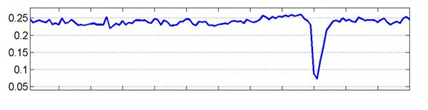

**Fig-8 Plotting EAR over time. The peak indicates closure and blinking of an eye.**

7. *Raising an alarm:*

A Beep sound of frequency 3500 is finally blown with the help of the sys module whenever a trigger is initiated after drowsiness is detected by the system. The system will be in a state of ringing the alarm until the driver doesn’t return back to its normal state.

**Code:** winsound.Beep(self.frequency, self.duration)

**IV. EXPERIMENTAL RESULTS**

We have successfully run our proposed method on a laptop with Corei5 8th generation having clock speed of 2.6Ghz with 8GB of RAM under TENSORFLOW environment using laptop’s inbuilt webcam of 0.9MP (1280*720). In this experiment, we examined our system on different people on all different scenarios to validate the output. The system works with high accuracy even with large hindrances like spectacles, dim light, noise etc.

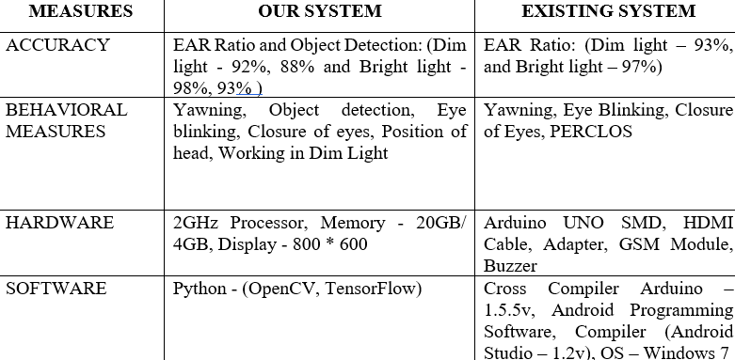

**Fig-9 Comparison Table**

**V. ADVANTAGES**

Driver drowsiness system has other advantages in the real world such as reducing road accidents or mishaps, practically applicable method, affordable and easy to use and integrate with other systems and eco-friendly. It can even detect 60+ other objects as well. This system can also serve in many fields like aircrafts, surveillance etc.

**VI. CONCLUSION AND FUTURE SCOPE**

Driver drowsiness systems are analysed and a system is developed to alert the driver. In this paper, the main focus has been kept to avoid accidents due to drowsiness and to alert drivers if this situation has arrived. The project uses image processing techniques to analyse the driver’s drowsiness by continuously detecting blinking of an eye. This project has been tested successfully among all the robust test cases. It has experimentally found that the system works with almost 100% accuracy when the lights are bright and favourable along with no hindrances between the camera and the person’s eye. With advanced image processing and shape prediction algorithms, the project has been implemented successfully.

Our system has a wide scope further. It can be directly integrated with any hardware system like Arduino to extend the functionality of the system. Also, it can be used in the system where high surveillance and monitoring is required with addition of high accuracy. Security alerts where 24*7 security is required, medical examining, online examination monitoring, hassle free driving are some other aspects where it can be moulded to make a better use of it.

**VIII. REFERNCES**

* Takei, Y., Furukawa, Y.: Estimate of driver’s fatigue through steering motion. In Man and Cybernetics, 2005 IEEE International Conference, Volume 2, pp. 1765-17770, 2005.
* N.Dalal and B. Triggs, “Histograms of oriented gradients for human detection, “Proc. – 2005 IEEE Comput. Soc. Conf. Comput. Vis. Pattern Recognition, CVPR 2005, vol I, pp. 886-893, 2005.
* T. Ito, S. Mita, K. Kazuhiro, T. Nakano, S. Yamamaoto, “Driver Blink Measurement by the Motion Picture Processing and its Applications to Drowsiness Detectin”, The IEEE 5th International Conference on Intelligent Systems, 2002.
* Hands-On Image Processing with Python: Expert Techniques for Advanced Image Analysis and Effective Interpretation of Image Data – book by Sandipan Dey.
* Omkar, RevatiBhor, Pranjal Mahajan, H.V. Kumbhar “Survey on Driver’s drowsiness detection system”, vol. 132,2015.
* Swathi Kale, Rashmi Bhadke, Anuja Sali, NanaSaheb Kadu “Drowsiness detection and warning system” IJARCST, Vol2, issue 2, 2014.
* M. Hemamalini, P. Muhilan “Accident prevention using eye blink sensor”, vol 1, Issue L11, 2017.
* Prakash Chaudhary, Rahul Sharma, Gautam Singh, Smarjeet Das “A Survey paper on Drowsiness Detection and Alarm system for Drivers.”, vol 3, Issue 12, 2016.
* Subbarao, K. Sahithya “Driver Drowsiness Detection System for vehicle Safety”, vol 8, Issue 6S4, ISN 2278-3075, 2019.
* Jyotsna Gabhane, Dhanashri Dixit, Pranali Mankar, Ruchika Kamble, Sayantani Gupta “Drowsiness Detection and Alert System: A Review”, vol 6, Issue 4, ISSN 2321-9653, 2018.